**Functional Document**

|  |  |
| --- | --- |
| **Application** | NGERP - Centra |
| **Service Bundle** | Sales Management |
| **Service Request** | Sales Order |

**Description:**

In **Compiere (NGERP - Centra)**, the "**Sales Order**" screen is a vital component of the ERP system that allows users to manage, track, and view sales orders across various regions.

**Workflow Process:**

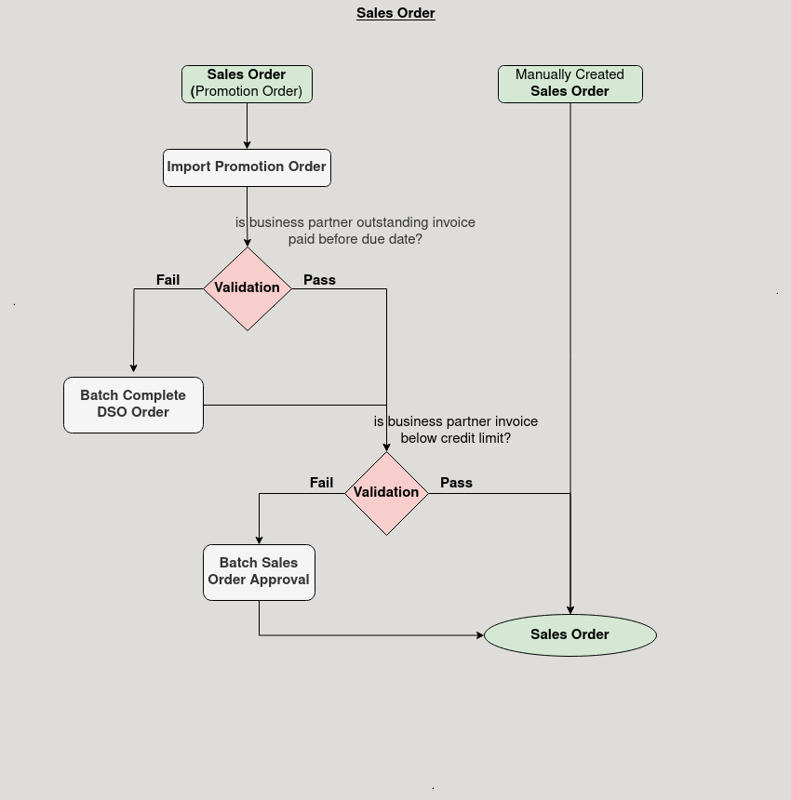

**Business Rules:**

* It is visible in both **HQ** and **ROW.**
* **Creation** is only possible in **ROW.**
* All Sales Orders should be visible in HQ, providing a consolidated view of transactions from all regions.
* Document status such as "Completed," "Draft," "Invalid," "Void," and "Inprogress" should all be visible for Sales Orders in HQ, ensuring comprehensive tracking.
* Each ROW in the Sales Order screen should represent a unique sales transaction, ensuring that all records are distinct and not duplicated.